**Contents**

**Introduction 1**

**Project 1**

**Design 1**

**Picture 2**

**Results 2**

**Packet Success Rate 2**

**Conclusions 3**

**Different 3**

**In Future 3**

**References 3**

**Appendix 4**

**Configurations 4**

**Servers (DHCP AND DNS): 4**

**Routers (EIGRP AND ACL): 7**

**ZAHVIA ELECTRONICS LTD**

**Introduction:**

Zahvia Electronics Ltd. is a new company is going to start operating in Pakistan. They are going to have three different buildings in Karachi, Islamabad and Lahore with 3 floors in each building, each floor is representing 1 department (means there are 3 departments in each building. Karachi building is the main branch of the office.

We need to connect the same department of each building and head office provide the network to all the department. There is the director of the company in the head office who can access all the department but different department cannot access each other.

**Project:**

**Design:**

* There should be 5 **PCs** and 1 **Laptop** in each floor of buildings and total number of employees which are 55.
* There is a need of 3 different servers for company’s internal functions and all three servers should be accessible in all systems within organization and apply DHCP and DNS service in these.
* There is a separate room for **server** and there is a separate room for Director in Karachi building on 3rd Floor. Therefore, there is a need of 6 PCs and 2 Laptops in Karachi Building 3rd Floor which should be able to connect all devices of company and should be extendable in case of need of new recruits of employees.
* We need three **VLAN** System in our building one for each department to communicate internally through interconnect switches like (**Finance, Office Employees, Production Center**).
* We require 3 **routers** with EIGRP and ACL Configuration which provide very fast rapid convergence times for changes in the network topology.

**Picture:**

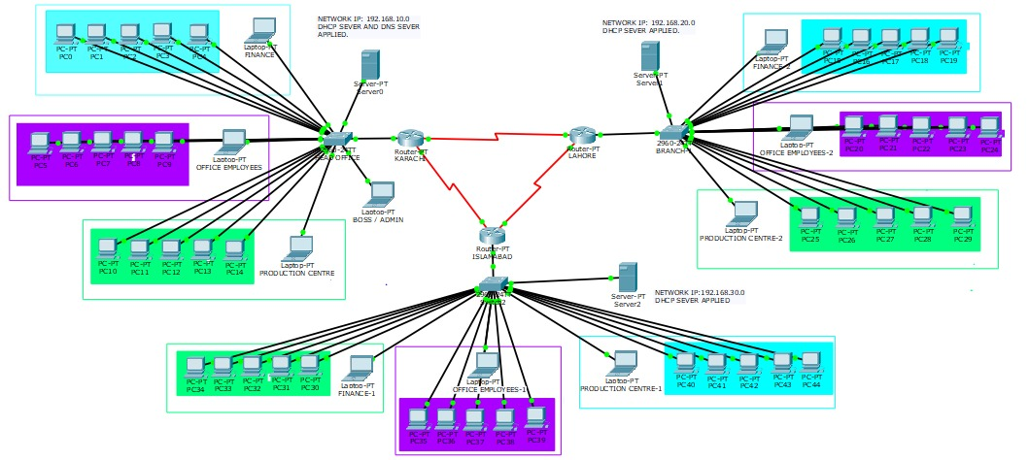

**Results:**

1. Every pc use html service of their respective networks through DNS service.
2. One network PC don’t use the service of another network server through ACL configuration in each router.
3. Each department PCS can communicate with respective department (**Finance, Office Employees, Production Center**) through separate vlan.
4. Admin communicate all PCs throughout all the networks.

**Packet Success Rate:**

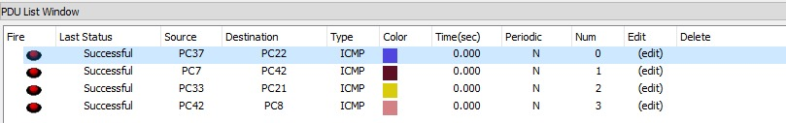

**Conclusions:**

We learned from this project that how different organization communicate through different networking ideas. We learned how different devices are connected in different departments and organizations. We learned how different protocols are used according to the situation.

**Different:**

One network PC can’t send packets to another network server by the using of ACL Configuration (PC22 to Karachi network server).

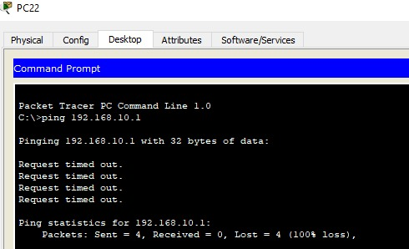

**In Future:**

This network can be use by any small and medium organization and in future we may add more ports and increase our network easily.

**References:**

**Data Communications and Networking Behrouz A. Forouzan 5th Edition.**

**Appendix:**

## **Configurations**

### **Servers (DHCP AND DNS):**

* **Server 0**

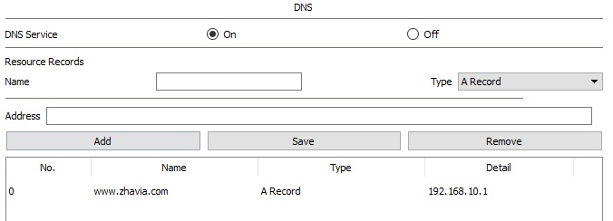

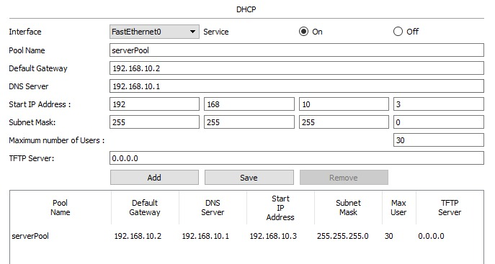

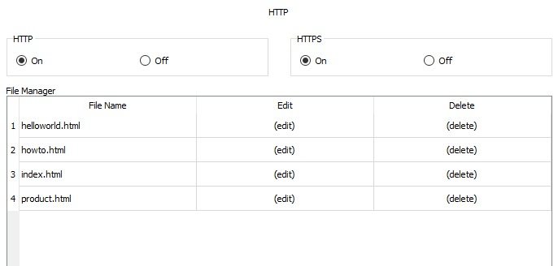

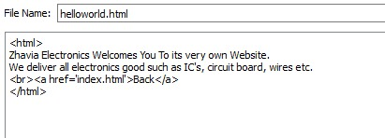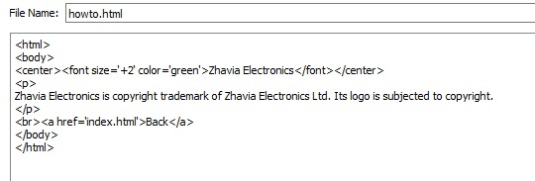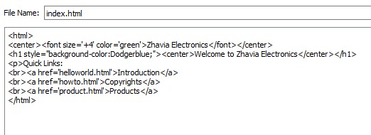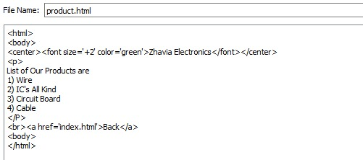

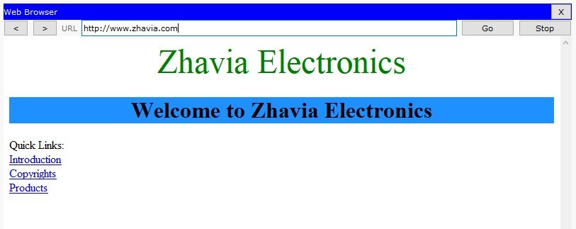

* **Server 1**

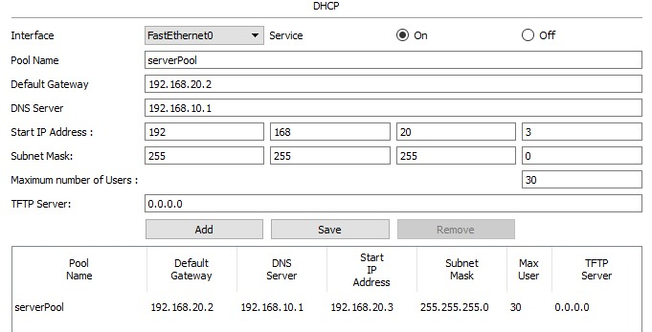

* **Server 2**

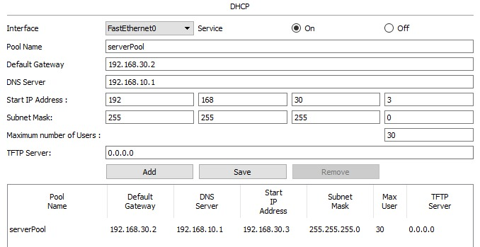

### **Routers (EIGRP AND ACL):**

* **KARACHI**

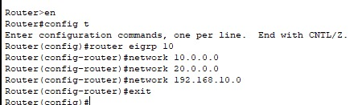

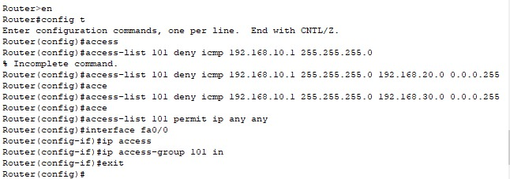

* **LAHORE**

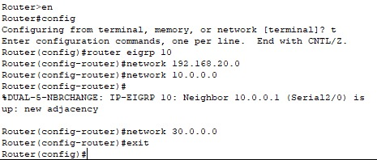

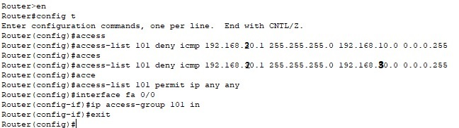

* **ISLAMABAD**

